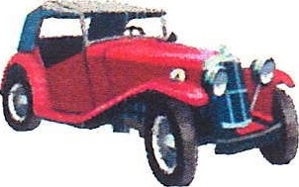Lititz Lion's 25th Car & Motorcycle Show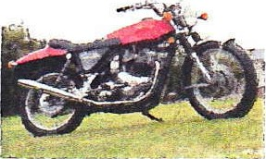
Wednesday, August 12, 2020

Registration Form
Join us in the town of Lititz for a night out. Over 200 vehicles and motorcycles will line Main Street. Enjoy DJ music, great food from our downtown retailers, and a trophy presentation at the end of the evening. All participants must be pre-registered and will receive a dash plaque.
WHERE: All vehicles will be staged at Bonfield Elementary School, 101 N Oak St., Lititz, PA 17543. A map has been enclosed for your convenience.
WHEN: Wednesday, August 12, 2020, 5:30-9 p.m. RAIN OR SHINE. Vehicles must arrive between 5:30 & 6:30 and must stay until the end of the show.
COST: $20 non-refundable donation for each vehicle.
Note: We will mail your admission card when we receive your registration form and check. You must present your admission card to enter.
For more information, please contact lititzlions@gmail.com or (717) 538-5080

cut here, keep top portion & return bottom
Car & Motorcycle Show Registration Form

NAME: _____________________________________ PHONE: ________________________________
ADDRESS: ____________________________________ CITY ____________________ ST ____ ZIP ___________

CZ
Email Address:

Signature:

Liability: In consideration of the right to participate- entrants, participants and spectators by execution of this release discharge the Lititz Lions Club, directors, or anyone connected with the management or presentation of this event of any and all known and unknown damages, injuries, losses and/or claims from any cause whatsoever that may be suffered by an entrant to his person or property.
Return this form and a $20 non-refundable check payable to: Lititz Lions Club
Mail to: Lititz Lions Club, PO Box 165, Lititz, PA 17543 by July 20, 2020 All cars & motorcycles MUST be Pre-Registered

